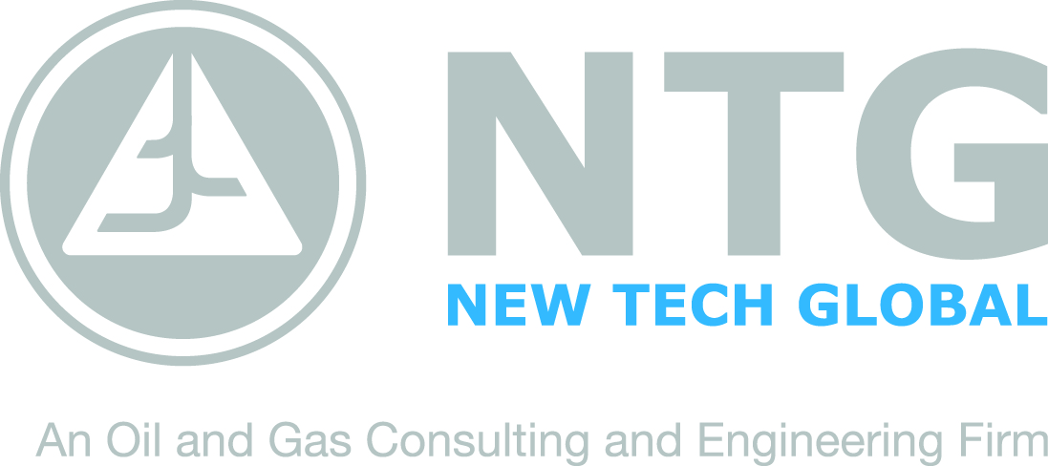 | 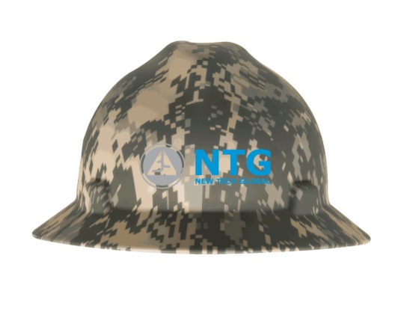
FOR IMMEDIATE RELEASE CONTACT: Rob Williams (281) 951-4330
rwilliams@newtecheng.com

New Tech Global Announces “Hard Hat Supporting Our Troops” Campaign
(Houston, Texas) – In an effort to support our troops currently deployed overseas and to bring greater awareness to the need to support our wounded veterans returning home, NTG has started the “Hard Hat Supporting Our Troops” campaign.

The Oil and Gas industry has always been known as a patriotic group with thousands of veterans serving as key leaders, as well as an industry that works to provide job opportunities to service men and women. In NTG’s continuous focus to be a leader in consulting and safety services, and demonstrate their support of wounded veterans, they took it upon themselves to offer their well site personnel the latest technology hard hats to replace their existing models. The new hard hats will be especially designed digital camouflage and come with additional information on how you can contribute and support veteran organizations.

By providing this service, NTG is able to show it’s appreciation to their consultant personnel, their dedication to safety and show their continued support for our troops and wounded veterans. New Tech Global and its leadership have committed to make a donation to recognized veteran organizations for every new digital camouflage hard hat it sends out. For more information on how to join New Tech Global’s effort in supporting our troops and how you may participate in the “Hard Hat Supporting Our Troops” campaign, please contact Rob Williams at rwilliams@newtecheng.com or call 281-951-4330.

About NTG

Today, New Tech Global (NTG) is recognized as a global leader in upstream oil and gas consultancy services. NTG is comprised of three primary business divisions that include Consulting, Engineering Services and Oilfield Solutions. For more information about NTG, visit the Company’s website at newtecheng.com. Follow NTG at www.facebook.com/newtechglobal and www.twitter.com/#!/newtechglobal
####

